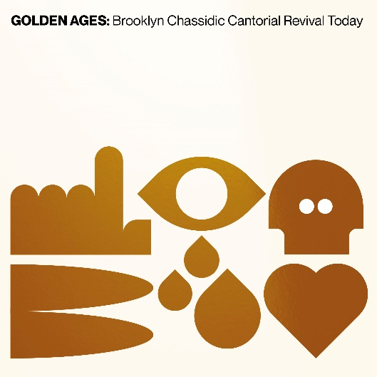

Golden Ages: Brooklyn cantorial revival today
Press Release

In today’s Brooklyn, there is a remarkable music revival bubbling with life, hidden away from view of most music fans. It is located in communities in Williamsburg and Borough Park, and its key players are young Chassidic singers. In the ultra-Orthodox community, older forms of Jewish music have largely been displaced by pop-music that sounds a lot like what you would hear on the mainstream radio, but with lyrics in Yiddish or prayer book Hebrew, tailored to pious religious themes. A small but vibrant group of young singers have taken up the style of pre-World War Two cantorial music as their art form of choice, performing tracks recorded almost a century ago as their key repertoire. While some of these singers grew up in families with elder cantors they could learn from, other artists discovered the music directly from old records. In what might look to outsiders like an environment that discourages self-expression, these artists delve into the past to find their own expressive style. Produced by scholar and musician Jeremiah Lockwood and recorded by engineer Gabe Roth at Brooklyn’s home of soul, Daptone Studios, Golden Ages is a celebration of new sounds culled from the hidden sonic world of “golden age” cantorial music.

The artists documented on this album, including luminaries like Yanky Lemmer, Yoel Kohn and Shimmy Miller, create new music shimmering with vitality and muscular virtuosity, but one with deep roots in the world of old Jewish sacred records. At the dawn of the 20th century, Jewish listeners were entranced by a new style of recorded cantorial music that was inspired by the synagogue but tailored to the dramatic format of new recording technology. Star cantors like Zawel Kwartin, Gershon Sirota and Yossele Rosenblatt offered Jewish listeners a musical representation of their spiritual lives committed to wax. The deeply emotive and wildly dramatic sound of cantorial records was a pop music phenomenon that was supported by impassioned fans, who bought records, went to cantorial concerts and immersed themselves in the sounds of prayer leading in the synagogue in a culture of sacred listening that has disappeared from Jewish life. On Golden Ages, cantorial revivalists brilliantly evoke deep listening practices that once permeated Jewish religious life, inviting listeners on a journey into the archive of sacred sound.

The recording star cantors of the 1920s imagined themselves as defenders of the folkloric Jewish past, endangered by the transformations of modernity. At the same time, cantorial music itself is deeply modern, twisting and transforming elements of old Jewish sound into art and personal expression. Cantorial revivalists of the 2020s walk in the footsteps of the old masters, transforming sounds of the past with new energy to address new needs for expressive power and soulful truth telling. Their music is a revolutionary new step in Jewish music, commandeering the skill and sound of an old sacred art form and harnessing it to the energy of Brooklyn today.

BANDCAMP

